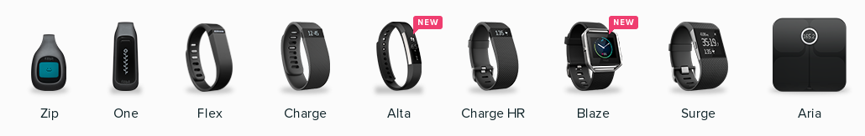
(Approx. 1236 words)

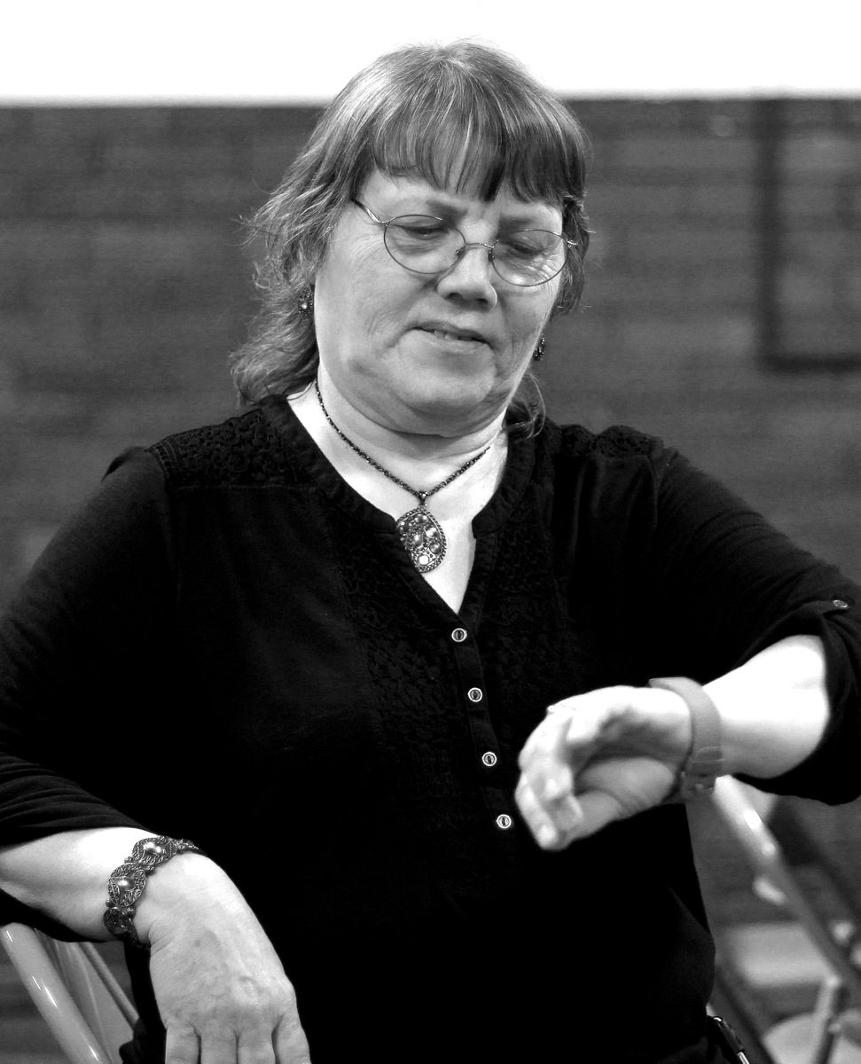
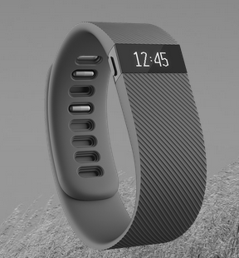

Quad-Cities Computer Society Meeting Review
Wearable Technology: Fitbit fitbit.com
Presented by Judi McDowell, QCS President
Reviewed by Joe Durham, Editor, Quad-Cities Computer Society, IA
May 2016 issue, Qbits
www.qcs.org
julee89 (at) gmail.com
joseph85_us (at) yahoo.com

Fitbit Charge HR

At a recent meeting, Judi McDowell, QCS president, shared her knowledge and experience with wearable technology. The pace of technological change is fast and these devices are now the “in” thing for groups of all ages. She focused on the Fitbit devices as she has a Fitbit Charge which is one of the newer models in the Fitbit line of devices.

She asked for a show of hands among the audience for those who currently use this technology. There were 6 hands: 3 had a Fitbit Charge, one had a Fitbit Alta, one had a Fitbit Flex, and one had a Garmin device. This indicates that the desire to use these new gadgets is growing day by day, even among our QCS members.

Judi gave us an historical overview of how these devices emerged on the scene. Like all technological revolutions the fitness tracking device has its origins in many diverse needs and slowly the growth of technological change brought it all together.

Amazingly, it has its origin in the creation of the lie detector in 1921. A lie detector measures electronically your pulse, blood pressure, and there are seniors on your skin to measure changes there.

Segue to 1961 in Japan. A professor wanted the means to track walking for health. He developed the pedometer, I am sure we have all seen these mechanical aids from time to time.

Now move to 1971 and car technology. The development of air bags brought forth the creation of the accelerometer which measures change in direction, an obvious requirement for air bag to deploy at the right moment in the event of a crash.

Now switch to 1974 and game technology was needed for the all of the new gaming controls, to help us enjoy and become a part of the experience. These advances help everyone navigate through Zelda, Donkey Kong and the rest.

1982 brought forth development from another direction; sports training. Devices appeared that monitored the athlete's heart rate.

In 1999 stationary bikes with monitoring and visual feedback were popular.

GPS technology came to the masses in the year 2000 when it was released for public use. Now there was an earth wide means of tracking movement.

A 3D accelerometer was developed in 2003 which allowed technicians to measure movement in all three directions: up, down, left and right, forward and backwards.

Take the mixture of all of these changes from 1921 to 2003, and a company was able put all of these functions into a small wearable size in 2008, Fitbit

The new models of Fitbit now monitor your heart rate, and sleep. All these functions designed to motivate us to a more healthy lifestyle with the means to monitor our goals in the device and online. James Park and Eric Freidmen were the creators of Fitbit. It is so popular that there are competitors in the marketplace from Apple, Android and Garmin.

In 2015 Fitbit was encouraged to issue an IPO and it is now worth around $3.7 billion. And Park is now #29 on the list of those 40 or under in wealth.

As a means of improving her lifestyle, Judi purchased a Fitbit Charge. She choose this model because it monitors steps, heart rate and has the time on it. When you purchase one, it recommends that you attach it two fingers above your wrist bone. It also has caller ID when configured with compatible mobile devices.

It comes with a USB charger, a dongle that you place in your computer through which you upload data to your Fitbit page online so that you can records your activity. She said that the battery life states 7 – 10 days, but it is not that long in her use of it, but that was not a big issue.

The Fitbit charge also monitors your sleep. Current health advice strongly recommends that we get enough sleep in this fast paced world and the Fitbit aids you in that accounting. Judi did wonders what it records when one falls asleep in the chair from time to time.

Judi then brought her Fitbit account online, this is displayed in what is called the Dashboard. This is the genius of the device, as you dongle the Fitbit periodically it uploads all of your data and helps you visually to see your progress and goals.

The Fitbit Charge will also track your movements as you exercise. One day she walked around a large building at her place many times and you could see her track recorded online as a series of circles in transit.

She did mention a couple of operating quirks. For example, when she was shopping in Walmart and her hands were on the shopping cart the lack of movement of her hands meant that the Fitbit charge was not tracking her steps. Apparently the Fitbit needs see change in your arm movement to record steps. For situations such as these you can tell Fitbit that you are walking a predetermined amount of time and it will account for steps accordingly.

The Fitbit Charge also tracks your movements on stairs. Judi's explanation of her resent stair movement was interesting. She arrived early before the QCS meeting and decided to walk about record and demonstrate the device. Nearby is Viele Park in Moline. There is a descending terraced set of steps. Going down was easy, but coming back was a bit of challenge. This walk was a good choice for exercise.

Her Fitbit Dashboard account of that travel indicated that her heart rate reached 153 beats per minute and that she was credited with going up 17 flights of stairs on her return back to the Butterworth Education center. By the time she entered the building her Fitbit Charge buzzed which meant that she reached her goal of over 10,000 steps for the day.

The online interface calculates calories burned. You can also input your food intake to see what you have taken in and the balanced burned for the day. Additionally you have the option of downloading your data to a spreadsheet so that you can monitor and analyze your progress.

If you purchase a premium subscription to the Fitbit service, a personal trainer will devise an exercise plan just for you. Judi mentioned that Fitbit Blog online is a good and enjoyable source for information and comment while using the devices.
You may have seen reports that Fitbit is being sued by some athletes for inaccurate results. With any measuring device of this type it is more noteworthy that you have the same device giving you data each day, it a base from which can accurately monitor your progress even though it may not tell you to the inch what your travel has been.
Judi concluded her remarks by observing that media forecasts see a 35% growth each year in personal tracking devices of this type for the next five years. It is certain that we all wish to improve our health status in life and devices of this nature will help move us along towards that goal. The QCS would like to thank Judi for her fine presentation and look into this new and emerging tech field.

